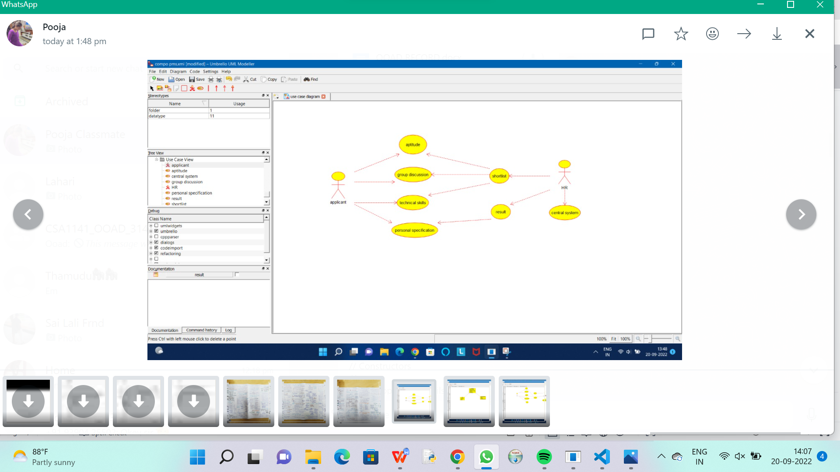

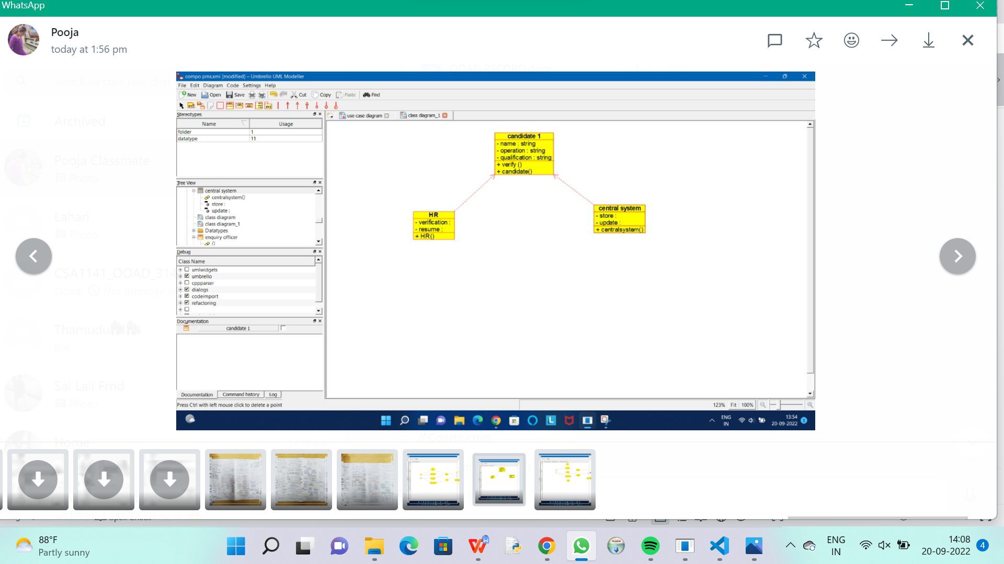

/**

* Class applicant_details

*/

public class applicant_details {

//

// Fields

//

//

// Constructors

//

public applicant_details () { };

//

// Methods

//

//

// Accessor methods

//

//

// Other methods

//

/**

*/

public void new_operation()

{

}

/**

*/

public void request_for_proof()

{

}

}

**

* Class candidate_1

*/

public class candidate_1 {

//

// Fields

//

private String name;

private String operation;

private String qualification;

//

// Constructors

//

public candidate_1 () { };

//

// Methods

//

//

// Accessor methods

//

/**

* Set the value of name

* @param newVar the new value of name

*/

private void setName (String newVar) {

name = newVar;

}

/**

* Get the value of name

* @return the value of name

*/

private String getName () {

return name;

}

/**

* Set the value of operation

* @param newVar the new value of operation

*/

private void setOperation (String newVar) {

operation = newVar;

}

/**

* Get the value of operation

* @return the value of operation

*/

private String getOperation () {

return operation;

}

/**

* Set the value of qualification

* @param newVar the new value of qualification

*/

private void setQualification (String newVar) {

qualification = newVar;

}

/**

* Get the value of qualification

* @return the value of qualification

*/

private String getQualification () {

return qualification;

}

//

// Other methods

//

/**

*/

public void verify_()

{

}

/**

*/

public void candidate()

{

}

}

/**

* Class HR

*/

public class HR {

//

// Fields

//

private void verification;

private void resume;

//

// Constructors

//

public HR () { };

//

// Methods

//

//

// Accessor methods

//

/**

* Set the value of verification

* @param newVar the new value of verification

*/

private void setVerification (void newVar) {

verification = newVar;

}

/**

* Get the value of verification

* @return the value of verification

*/

private void getVerification () {

return verification;

}

/**

* Set the value of resume

* @param newVar the new value of resume

*/

private void setResume (void newVar) {

resume = newVar;

}

/**

* Get the value of resume

* @return the value of resume

*/

private void getResume () {

return resume;

}

//

// Other methods

//

/**

*/

public void HR()

{

}

}